Operating Systems, Security and Network
Week 1 Lab Report: Linux Fundamentals (Files, APT & C Programming)

Part I: File Operations
Task 1.1: Create and Navigate to Lab Directory
$ mkdir ~/linux_lab
cd ~/linux_lab

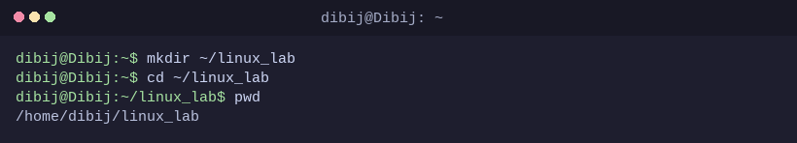

Task 1.2: Create and Edit File with Nano
$ nano greeting.txt
# Type: 'Hello Linux!' -> Save (Ctrl+O, Enter) -> Exit (Ctrl+X)

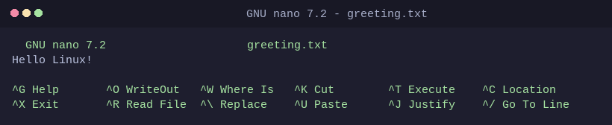

Task 1.3: View File Content
$ cat greeting.txt

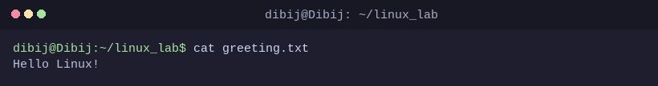

Task 1.4: Copy and Rename File
$ cp greeting.txt backup.txt
mv backup.txt old_greeting.txt

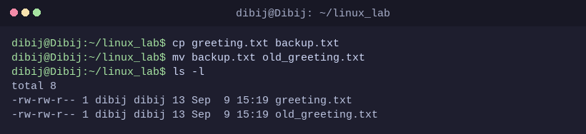

Task 1.5: Remove Files and Directories
$ rm old_greeting.txt
mkdir temp_dir
rmdir temp_dir

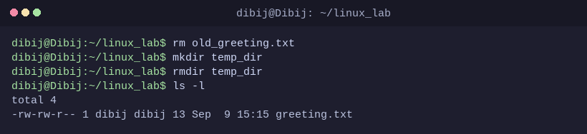

Task 1.6: Check Permissions
$ ls -l greeting.txt

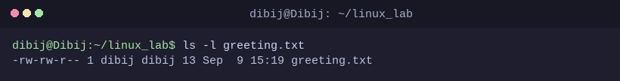

Part II: APT Package Management
Task 2.1: Update Package List
$ sudo apt update

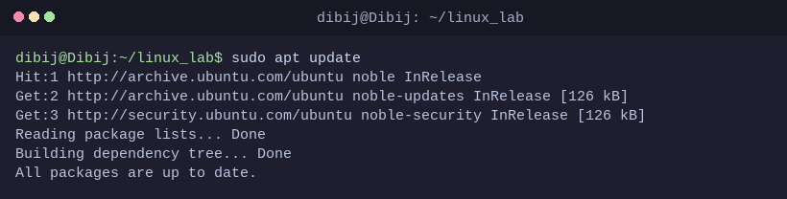

Task 2.2: Install C Compiler (GCC / build-essential)
$ sudo apt install build-essential -y

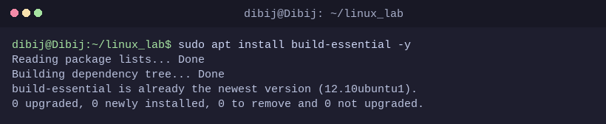

Task 2.3: Verify GCC Installation
$ gcc --version

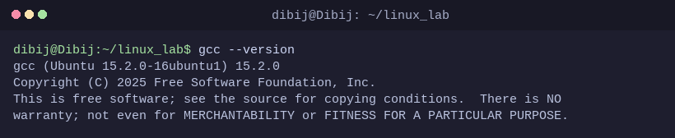

Task 2.4: Search for Packages
$ apt search python3

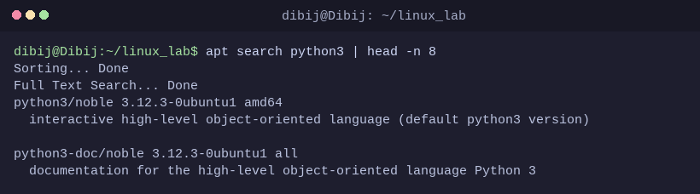

Part III: C Compilation & Iterative Development
Task 3.1: Write C Source Code (hello.c)
$ nano hello.c
#include <stdio.h>
int main() {
int a = 10, b = 5;
printf("Hello, Linux Lab!\n");
printf("Sum of %d and %d is %d\n", a, b, a + b);
return 0;
}

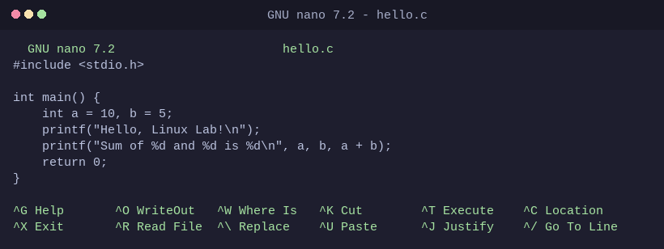

Task 3.2: Compile and Run Program
$ gcc hello.c -o hello_program
ls -l hello_program
./hello_program

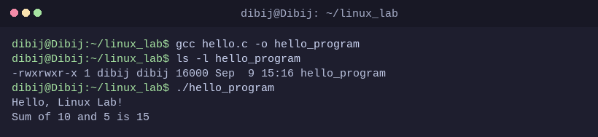

Task 3.3: Compile with Warnings Enabled (-Wall)
$ gcc -Wall hello.c -o hello_program_warn
./hello_program_warn

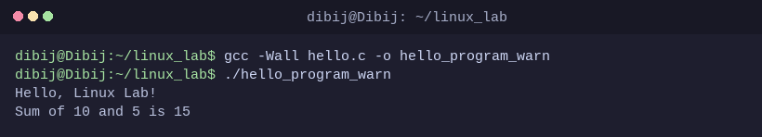

Task 3.4: Modify Values & Recompile
$ # nano hello.c (change a=100, b=200)
gcc -Wall hello.c -o hello_program
./hello_program

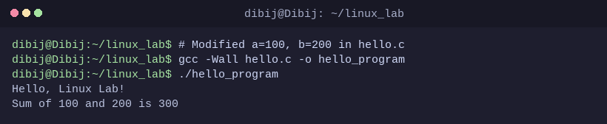

Part IV: Cleanup & Verification
Task 4.1: Return Home & List Files with Details
$ cd ~
ls -lh ~/linux_lab/

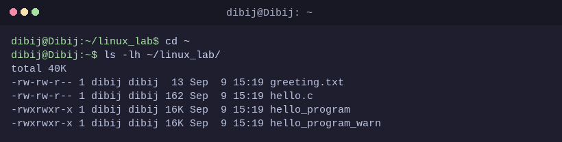

Task 4.2: Final Review & Optional Cleanup
$ cat ~/linux_lab/hello.c
# (Optional) rm -rf ~/linux_lab

